SE Minnesota

Disaster Health Coalition

Enhancing Regional Preparedness, Response and Recovery

Agenda

October 17, 2017; 8:45 AM – 4:30 PM

Location: 1001 14th St NW Rochester – Assisi Heights, Auditorium 1-50A

Webinar Option: Info Provided on Page 3.

Please register via SurveyMonkey:
https://www.surveymonkey.com/r/MQ2HKM2
October 17, 2017

Time | Agenda Item | Presenter | Location
8:00 | Arrival/Networking/Light Breakfast | NA | 1-50A, Auditorium
8:45 | Welcome & Agenda Overview | Byron Callies | 1-50A, Auditorium
9:00 | State of the Region Current Capabilities | Byron Callies | 1-50A, Auditorium
9:30 | The Orlando Nightclub Massacre  The Attack, The Medical Response, The Aftermath and Recovery | Gary Parrish, MD, FACEP | 1-50A, Auditorium
11:00 | Break
11:15 | Stop the Bleed Training  Provided by the Southern Minnesota Regional Trauma Advisory Committee | Gwen D. Meyer, M.S.N., R.N. Carol R. Immermann, R.N. | 1-50A, Auditorium
12:00 | Lunch |  | Dining Hall
1:00 | Regional Risk Profile | Jay Johnson | 1-50A, Auditorium
1:30 | Regional Emergency Preparedness Plan | Byron Callies | 1-50A, Auditorium
2:00 | Psychological First Aid Training  A Community Support Model | Christina M. Coyle, L.I.C.S.W. | 1-50A, Auditorium
2:30 | Break
2:45 | Psychological First Aid Training  A Community Support Model | Christina M. Coyle, L.I.C.S.W. | 1-50A, Auditorium
4:15 | Closing Remarks | Byron Callies | 1-50A, Auditorium
4:30 | Depart

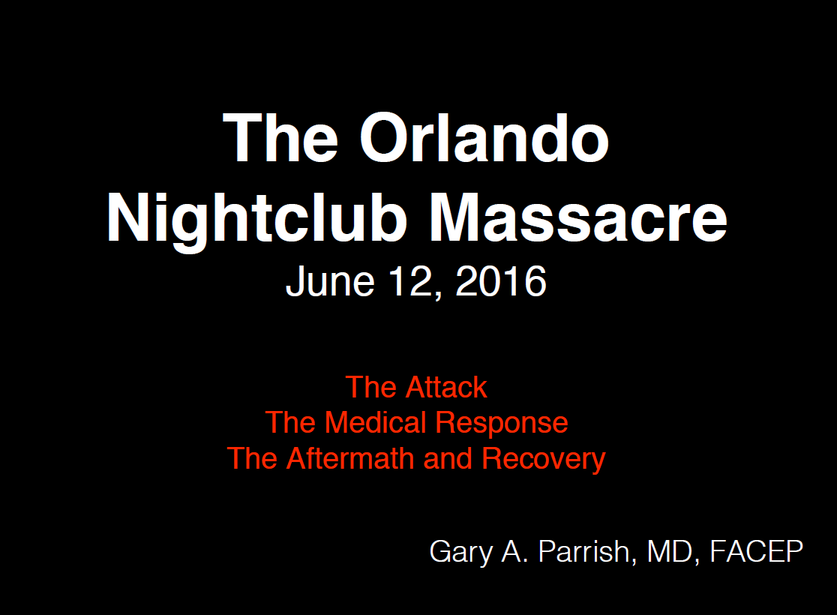
Dr. Parrish is the Medical Director of the Emergency Department at Orlando Health/Orlando Regional Medical Center in Orlando, Florida. He also serves as the clinical chairman of the Department of Emergency Medicine at ORMC and is a faculty member in their Emergency Medicine residency training program. He attended medical school at the University of Alabama in Birmingham and residency at Geisinger Medical Center in Danville, Pennsylvania. He is a clinical associate professor at the University Of Florida School Of Medicine and is currently a board-certified emergency physician in his 31st year of clinical practice. He was on duty in the Emergency Department at ORMC on June 12, 2016, and cared for victims of the Pulse Nightclub shooting tragedy.

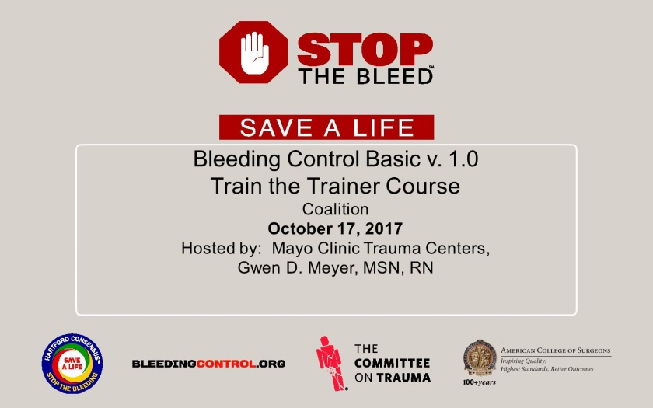
Everyone needs to be empowered to be an immediate responder in a crisis situation. Bystanders are usually the first people on the scene, and they can save a life with effective bleeding control.

Whether faced with an accident or an active shooter situation, everyone must be able to “Stop the Bleed.”

According to the Department of Homeland Security, it can take less than five minutes for someone to bleed out. EMS and other forms of help often can take longer to arrive on scene. So it’s vital that everyone has the knowledge and the tools to stop bleeding before it’s too late. The Stop the Bleed campaign is critical to savings lives in America.]

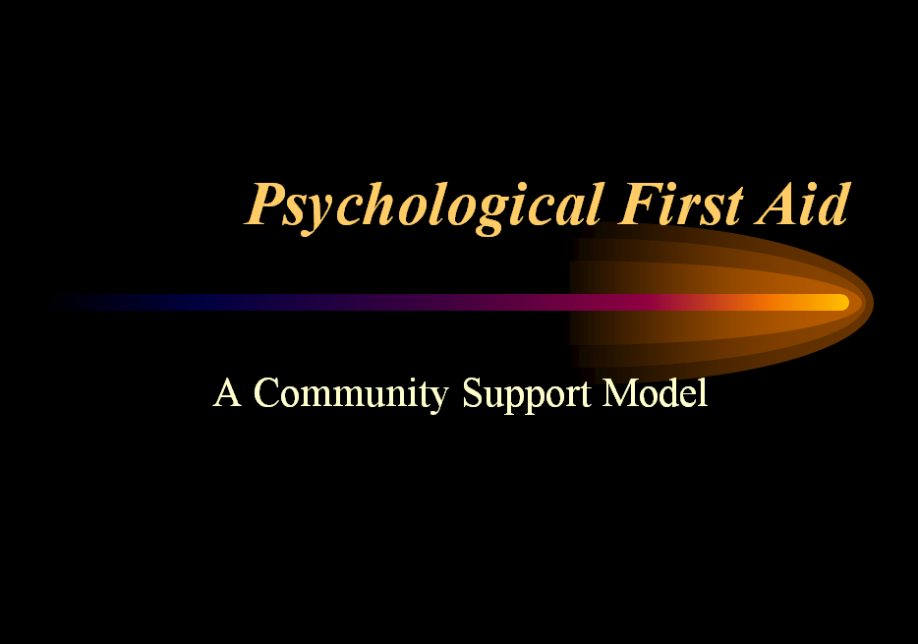

Psychological First Aid includes evidenced-based culturally-informed strategies that can be used with children, adolescents and adults who experience a stressful or traumatic event. Techniques can also be used by first responders to support resiliency among team members. Interventions can be applied immediately on scene. The goal is to prepare responders, reduce initial distress reactions and strengthen adaptive coping skills to promote heathy recovery. Training includes pocket guide to remind responders of components of Psychological First Aid and self-care tips.

SE Minnesota

Disaster Health Coalition

Enhancing Regional Preparedness, Response and Recovery

WEBINAR ACCESS INFORMATION

SEMN DHC Compact Meeting

Step 1: Dial-In

U.S. & Canada: 866.365.4406

Access Code: 2662083

Step 2: Web Login

https://cc.callinfo.com/r/1xp7lsms8iyae&eom

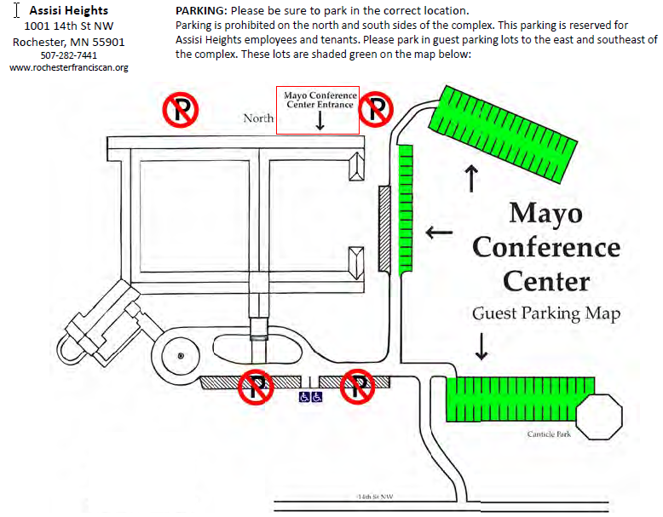

SE Minnesota

Disaster Health Coalition

Enhancing Regional Preparedness, Response and Recovery

