

[Name]
[Exercise/Incident type] Exercise/Incident
After Action Report

Exercise/Incident Date: [Enter date]
REPORT DATE: [Enter date]

Table of Contents
Handling Instructions iii
Executive Summary 1
Section 1: Exercise/Incident Overview 2
Section 2: Exercise/Incident Design Summary 3
Exercise/Incident Background 3
Exercise/Incident Purpose 3
Exercise/Incident Capabilities and Objectives 3
Participants 4
Exercise/Incident Format 4
Scenario 4
Section 3: Analysis of Capabilities 5
Capability 1: 5
Capability 2: «Capabilities2Capability» 6
Capability 3: «Capabilities3Capability» 7
Capability 4: «Capabilities4Capability» 8
Capability 5: «Capabilities5Capability» 9
Capability 6: «Capabilities6Capability» 9
Capability 7: «Capabilities7Capability» 10
Capability 8: «Capabilities8Capability» 10
Capability 9: «Capabilities9Capability» 11
Capability 10: «Capabilities10Capability» 11
Section 4: Conclusion 13
Appendix A: Participant Feedback Summary 1
Appendix B: Improvement Plan 1

Section 1: Exercise/Incident Overview
Exercise/Incident Name: [Exercise/Incident Name]
Type of Exercise/Incident: [Exercise/Incident Type]
Date: [Exercise/Incident Date]
Location:
Mission: Response
Incident/Scenario Description:
Target Capabilities:

Section 2: Exercise/Incident Summary

Exercise/Incident Report Purpose
The purpose of this Exercise/Incident report is to:

Exercise/Incident Background
[Organization] recognizes the need to protect the public from, and mitigate the consequences of, the hazards associated with disasters, including the necessity for a properly integrated response to such an incident. With this responsibility in mind, [Organization] developed policies and procedures to respond to disasters.

Exercise Requirements [remove for incident]
The current Department of Homeland Security (DHS) and Department of Health and Human Services – Office of the Assistant Secretary for Preparedness and Response (ASPR) grants require organizations and communities to conduct Exercise/Incidents to improve disaster response operations capabilities. The Joint Commission requires hospitals and ambulatory care facilities to conduct Exercise/Incidents periodically. Additionally, the Health System Preparedness Program (HSPP) requires periodic Exercise/Incidents to assess specific regional response capabilities. [Organization] recognizes the need to understand expectations, roles, and responsibilities of departments and external partners during an emergency and disaster incidents.

Exercise/Incident Capabilities and Objectives [remove for incident]
Capabilities-based planning focuses on planning under uncertainty, since the next danger or disaster can never be forecast with complete accuracy. The capabilities listed below were selected by the Exercise planning team. These capabilities provided the foundation for development of the Exercise objectives and scenario:

Note: The six core emergency management function areas defined by The Joint Commission were also considered for scenario and question development/after action review.

Objectives [remove for incident]
Exercise design objectives are focused on assessing response capabilities. The Exercise focused on the following design objectives selected by the Exercise planning team:

The [name] Exercise/Incident required response by frontline staff and activation of the Hospital Incident Command System (HICS).

Participants
Internal | External
[copy from final participant listing]

Exercise Format [remove for incident]
To create a more realistic timeline for Exercise/Incident player activities to allow for effective assessment of current capabilities and limitations, the Exercise/Incident program involved a [Include as appropriate:
Tabletop Exercise to provide HICS an opportunity to discuss…
Functional Exercise involving simulation of patient arrival/movement to……
Full-Scale Exercise involving movement of role-player/mannequin patients to allow for hands-on activities to be performed, such ….]

Scenario/Incident Details
The Exercise/Incident involved a response to

Section 3: Analysis of Capabilities
Table 1 includes the Exercise/Incident objectives, aligned core capabilities, and performance ratings for each core capability as observed during the Exercise/Incident and determined by the evaluation team.
Ratings Definitions:
Performed without Challenges (P): The critical tasks associated with the capability were completed and achieved the objective(s) and did not negatively impact the performance of other activities. Performance of this activity did not contribute to additional health and/or safety risks for the public or for emergency workers, and it was conducted in accordance with applicable plans, policies, procedures, regulations, and laws.
Performed with Some Challenges (S): The critical tasks associated with the capability were completed and achieved the objective(s) and did not negatively impact the performance of other activities. Performance of this activity did not contribute to additional health and/or safety risks for the public or for emergency workers, and it was conducted in accordance with applicable plans, policies, procedures, regulations, and laws. However, opportunities to enhance effectiveness and/or efficiency were identified.
Performed with Major Challenges (M): The critical tasks associated with the capability were completed and achieved the objective(s), but some or all of the following were observed: demonstrated performance had a negative impact on the performance of other activities; contributed to additional health and/or safety risks for the public or for emergency workers; and/or was not conducted in accordance with applicable plans, policies, procedures, regulations, and laws.
Unable to be Performed (U): The critical tasks associated with the capability were not performed in a manner that achieved the objective(s).
Capability | Objective | P | S | M | U
 |  | X
 |  |  | X
 |  |  |  | X
 |  |  |  |  | X

This section of the report reviews the observations related to response capabilities and includes recommendations for improvement.

Capability:
Capability Description:

Strengths
The [full/partial] capability level can be attributed to the following strengths:
Strength 1:
Strength 2:
Strength 3:

Areas for Improvement
The following areas require improvement to achieve the full capability level:
  - Area for Improvement: [Include brief description]
Reference:
Analysis:
[Describe the actions or lack of actions during the Exercise/Incident related to this area for improvement. Provide the reason or justification for the recommendation. Include any charts/graphs or articles/references that support your analysis.]
Recommendations:
    - [Enter recommendation]
    - [Enter recommendation]
  - Area for Improvement: [Include brief description]
Reference: [Include reference as appropriate]
Analysis:
[Describe the actions or lack of actions during the Exercise/Incident related to this area for improvement. Provide the reason or justification for the recommendation. Include any charts/graphs or articles/references that support your analysis.]
Recommendations:
    - [Enter recommendation]
  - Area for Improvement: [Include brief description]
Reference: [Include reference as appropriate]
Analysis:
[Describe the actions or lack of actions during the Exercise/Incident related to this area for improvement. Provide the reason or justification for the recommendation. Include any charts/graphs or articles/references that support your analysis.]
Recommendations:
    - [Enter recommendation]
  - Area for Improvement: [Include brief description]
Reference: [Include reference as appropriate]
Analysis:
[Describe the actions or lack of actions during the Exercise/Incident related to this area for improvement. Provide the reason or justification for the recommendation. Include any charts/graphs or articles/references that support your analysis.]
Recommendations:
    - [Enter recommendation]

Capability:
Capability Description:

Strengths
The [full/partial] capability level can be attributed to the following strengths:
Strength 1:
Strength 2:
Strength 3:
  - Area for Improvement: [Include brief description]
Reference: [Include reference as appropriate]
Analysis:
[Describe the actions or lack of actions during the Exercise/Incident related to this area for improvement. Provide the reason or justification for the recommendation. Include any charts/graphs or articles/references that support your analysis.]
Recommendations:
    - [Enter recommendation]
  - Area for Improvement: [Include brief description]
Reference: [Include reference as appropriate]
Analysis:
[Describe the actions or lack of actions during the Exercise/Incident related to this area for improvement. Provide the reason or justification for the recommendation. Include any charts/graphs or articles/references that support your analysis.]
Recommendations:
    - [Enter recommendation]
    - [Enter recommendation]
  - Area for Improvement: [Include brief description]
Reference: [Include reference as appropriate]
Analysis:
[Describe the actions or lack of actions during the Exercise/Incident related to this area for improvement. Provide the reason or justification for the recommendation. Include any charts/graphs or articles/references that support your analysis.]
Recommendations:
    - [Enter recommendation]
  - Area for Improvement: [Include brief description]
Reference: [Include reference as appropriate]
Analysis:
[Describe the actions or lack of actions during the Exercise/Incident related to this area for improvement. Provide the reason or justification for the recommendation. Include any charts/graphs or articles/references that support your analysis.]
Recommendations:
    - [Enter recommendation]

Capability:
Capability Description:

Strengths
The [full/partial] capability level can be attributed to the following strengths:
Strength 1:
Strength 2:
Strength 3:
  - Area for Improvement: [Include brief description]
Reference: [Include reference as appropriate]
Analysis:
[Describe the actions or lack of actions during the Exercise/Incident related to this area for improvement. Provide the reason or justification for the recommendation. Include any charts/graphs or articles/references that support your analysis.]
Recommendations:
    - [Enter recommendation]
  - Area for Improvement: [Include brief description]
Reference: [Include reference as appropriate]
Analysis:
[Describe the actions or lack of actions during the Exercise/Incident related to this area for improvement. Provide the reason or justification for the recommendation. Include any charts/graphs or articles/references that support your analysis.]
Recommendations:
    - [Enter recommendation]
  - Area for Improvement: [Include brief description]
Reference: [Include reference as appropriate]
Analysis:
[Describe the actions or lack of actions during the Exercise/Incident related to this area for improvement. Provide the reason or justification for the recommendation. Include any charts/graphs or articles/references that support your analysis.]
Recommendations:
    - [Enter recommendation]
  - Area for Improvement: [Include brief description]
Reference: [Include reference as appropriate]
Analysis:
[Describe the actions or lack of actions during the Exercise/Incident related to this area for improvement. Provide the reason or justification for the recommendation. Include any charts/graphs or articles/references that support your analysis.]
Recommendations:
    - [Enter recommendation]

Capability:
Capability Description:

Strengths
The [full/partial] capability level can be attributed to the following strengths:
Strength 1:
Strength 2:
Strength 3:
  - Area for Improvement: [Include brief description]
Reference: [Include reference as appropriate]
Analysis:
[Describe the actions or lack of actions during the Exercise/Incident related to this area for improvement. Provide the reason or justification for the recommendation. Include any charts/graphs or articles/references that support your analysis.]
Recommendations:
    - [Enter recommendation]
  - Area for Improvement: [Include brief description]
Reference: [Include reference as appropriate]
Analysis:
[Describe the actions or lack of actions during the Exercise/Incident related to this area for improvement. Provide the reason or justification for the recommendation. Include any charts/graphs or articles/references that support your analysis.]
Recommendations:
    - [Enter recommendation]
  - Area for Improvement: [Include brief description]
Reference: [Include reference as appropriate]
Analysis:
[Describe the actions or lack of actions during the Exercise/Incident related to this area for improvement. Provide the reason or justification for the recommendation. Include any charts/graphs or articles/references that support your analysis.]
Recommendations:
    - [Enter recommendation]
  - Area for Improvement: [Include brief description]
Reference: [Include reference as appropriate]
Analysis:
[Describe the actions or lack of actions during the Exercise/Incident related to this area for improvement. Provide the reason or justification for the recommendation. Include any charts/graphs or articles/references that support your analysis.]
Recommendations:
    - [Enter recommendation]

Appendix A: Participant Feedback Summary
Participants were provided the opportunity to rate their own knowledge and/or skills related to three assessment factors. In general, as a result of the Exercise, participants felt more confident in their abilities to respond to emergencies. The rating scale was one through five with one indicating “strongly disagree” and five indicating “strongly agree.” No “player” participant rated any of the statements less than “four.”
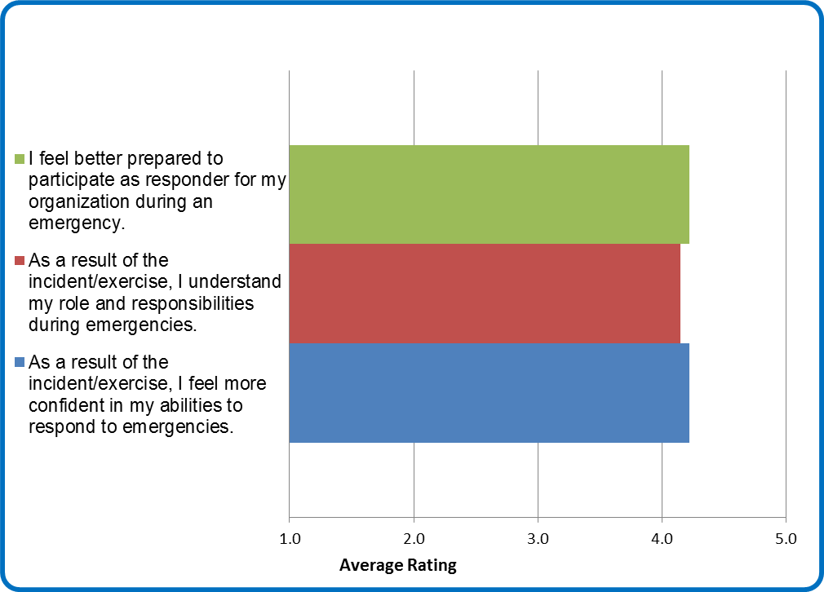
In addition to a self-assessment, participants were asked to provide input based on their observations. Specific strengths and areas for improvement documented by participants have been captured in the analysis section of this report.
[Remove for Incidents] Participants were also provided the opportunity to rate exercise design and conduct. The rating scale was one through five with one indicating “strongly disagree” and five indicating “strongly agree.” The ratings are consistent with ratings from other exercises.
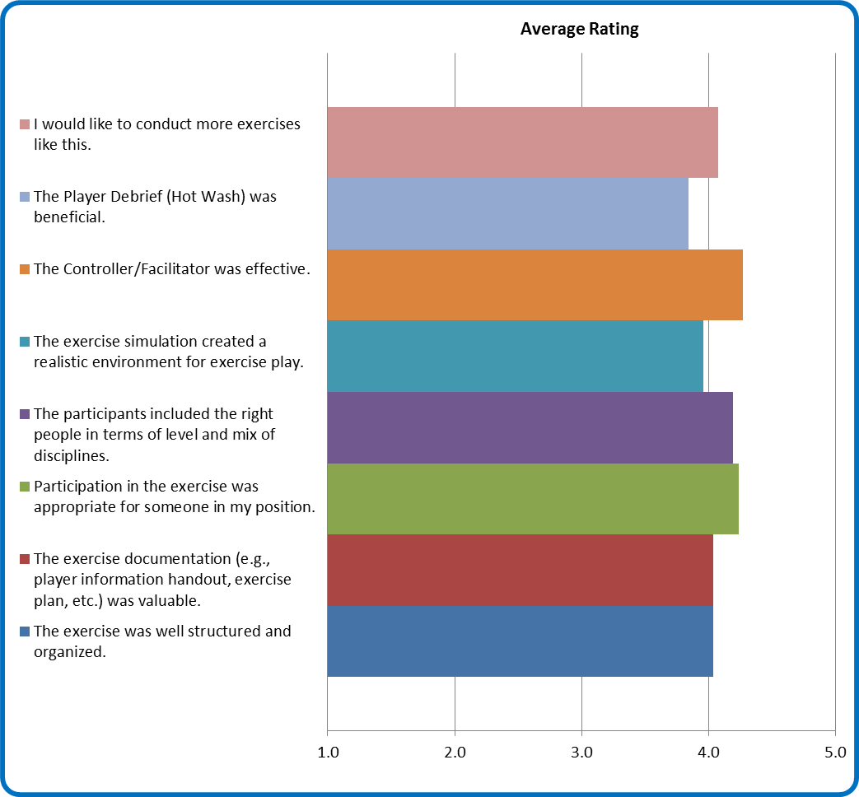
Highlights of some of the comments from participants:
- [Insert relevant comments]
[Summary of participant feedback comments.]
All comments for improvement should be considered in the future by exercise planning teams. Specific opportunities to assess [insert topics] should be included, to the degree possible, in all future operations-based exercise.

Appendix B: Improvement Plan
Legend
Aligned Committee |  | Priority Definitions
HALT = | Hospital Administration Leadership Team | Priority 1: | Just do it; top priority. (3 months.)
EPP = | Emergency Preparedness Plan Committee | Priority 2: | Appropriate to accomplish after Priority 1 items are complete. (6-9 months.)
HICS = | HICS Coordinating Group | Priority 3: | Appropriate to accomplish after Priority 2 items are complete. (12-18 months.)
EDEPC = | Emergency Department Emergency Preparedness Committee | Priority 4: | Do not initiate unless prioritized to higher level as a direct result of changes in conditions.
HMC = | HazMat Decon Workgroup
MCI = | Mass Casualty Incident Workgroup
NEPC = | Nursing Emergency Preparedness Committee

TJC EM Core Functions | Capability | Recommendation | Aligned Committee | Accountable Person/ Action Staff | Completion Date | Priority
Choose an item. | Choose an item. | [List recommendation with paragraph number and hyperlink] | Choose an item. |  | Click here to enter a date. | Choose an item.
Choose an item. | Choose an item. | [List recommendation with paragraph number and hyperlink] | Choose an item. |  | Click here to enter a date. | Choose an item.
Choose an item. | Choose an item. | [List recommendation with paragraph number and hyperlink] | Choose an item. |  | Click here to enter a date. | Choose an item.
Choose an item. | Choose an item. | [List recommendation with paragraph number and hyperlink] | Choose an item. |  | Click here to enter a date. | Choose an item.
Choose an item. | Choose an item. | [List recommendation with paragraph number and hyperlink] | Choose an item. |  | Click here to enter a date. | Choose an item.
Choose an item. | Choose an item. | [List recommendation with paragraph number and hyperlink] | Choose an item. |  | Click here to enter a date. | Choose an item.

